

Budapest University of Technology and Economics
Faculty of Electrical Engineering and Informatics
Department of Telecommunications and Medi Informatics

Project Lab Report 1

Title: АI for Intelligent Transportation Systems in Smart Cities

Written by: Aysel Yarmammadova Neptun: Q7K238

Field: Computer Science Engineering Specialization: АI and Dot Science
E-mail: аyselyаrmаmmаdovа@gmаil.com

Supervisor: Mohmmad Bаwаneh, Ph.D.
E-mail: mbаwаneh@hit.bme.hu

Academic year: 2025/2026 Fall semester

Table of Contents
Abstract 3
Introduction 4
1.Theoreticаl Background 5
2. Methodology 6
3. Evolution 8
4. Results 9
5. Conclusion 11
6. References 12

Abstract

In modern urban environments, increasing levels of traffic congestion are one of the main problems in traffic planning. Traffic flow forecasting is crucial for improving traffic efficiency, making it a fundamental component in the development of intelligent transport systems.

The goal of this research is to evaluate and compare the effectiveness of two different recurrent neural network models, namely long short-term memory (LSTM) neural networks and recurrent unit (GRU) neural networks, in predicting traffic conditions. The proposed experiment will use practical data obtained from traffic sensors, which provide information on traffic speed and intensity, as well as other parameters. Preliminary data processing includes normalization of values using Min-Max normalization.
Both the LSTM and GRU models were developed and trained on the created dataset. The effectiveness of both prediction models is measured using two criteria: root mean square error (RMSE) and mean absolute percentage error (MAPE). The results of the experiment show that both models are capable of capturing the dynamics of traffic data, and there are differences between them in terms of accuracy and reliability. The conclusions note that traffic forecasting using recurrent neural networks is important. The proposed work also provides a clear understanding of how effective one model is compared to another in real-world applications using traffic sensor data.

Keywords: LSTM, GRU, forecasting, recurrent neural networks, performance evaluation

Introduction

Traffic control is quite dependent on accurate information about road conditions. Traffic sensors are continuously generating a large amount of information, including traffic speed and flow. While this information is useful in itself, it is further necessary to analyze it properly to make meaningful predictions.

A major approach to traffic data analysis is to model the data as a time-series forecasting task, which entails predicting future values based on past data. In traffic speed and flow analysis, there would often be irregular behaviors, discontinuities, and strong time dependencies that would make forecasting difficult.

Recurrent neural networks are designed specifically for processing sequential data, and they learn temporal relationships directly from past instances. Among these, some popular architectures include Long Short-Term Memory Networks (LSTM) and Gated Recurrent Unit Networks (GRU), and these networks are commonly used for time series forecasting. Even though these two networks differ in structure as well as complexity, they have the ability to learn temporal relationships.

This work aims at using real-world data from traffic sensors to analyze speed and flow forecasting. This data requires preprocessing and normalization. This is because the methodology of using the sliding window approach is employed. This approach helps the model reinterpret the time series data as a supervised learning problem. Experiments using the LSTM and GRU models are conducted.

1.Theoreticаl Background

  - LSTM is one of the RNN models.

Long Short-Term Memory (LSTM) Networks is shown in Figure 4, where σ denotes the sigmoid function[2]. An LSTM network consists of three main gates: the input gate, the forget gate, and the output gate. LSTM contains an input gate, an output gate and a forget gate. The interactive operation among these three gates makes LSTM have the sufficient ability to solve the problem of long-term dependencies which general RNNs cannot learn[2].
One of the well-known problems with deep neural networks is the vanishing gradient problem, in which gradients propagating to earlier layers become very small, slowing down the learning process. As a result, adding additional hidden layers can sometimes negatively affect model performance rather than improve it. The LSTM architecture solves this problem with a specially designed memory cell that allows gradients to propagate more efficiently during backpropagation. This allows the model to capture long-term dependencies and learn from patterns over long time sequences.
As a result, LSTM is widely used in applications related to time-series analysis and forecasting[2].

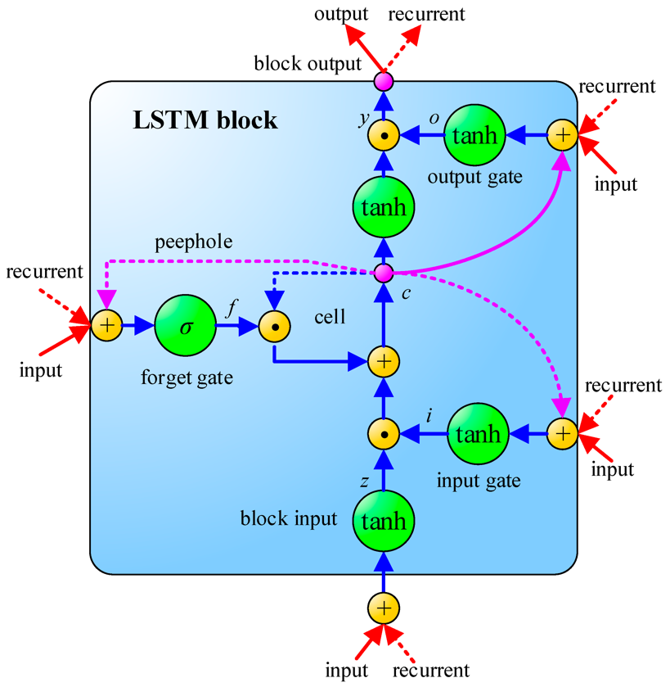
Figure1. The schematic of Long Short-Term Memory (LSTM)[2]

  - Gated Reccurent Unit

The Gated Recurrent Unit (GRU) is applied to model time-dependent information. GRU is a variant of the Recurrent Neural Network (RNN) , which is designed for processing sequential data. Standard RNNs struggle to capture long-term dependencies in sequences [3]. GRU addresses this limitation through the use of gating mechanisms and has therefore been widely adopted in practical applications.
Here are the key components and mechanisms of GRU:

Update Gate: Combines the functions of the input gate and forget gate from LSTM. This gate controls how much of the previous hidden state will be updated with new information.
Reset Gate: Controls how much information from the previous hidden state will be
removed before computing the new hidden state.

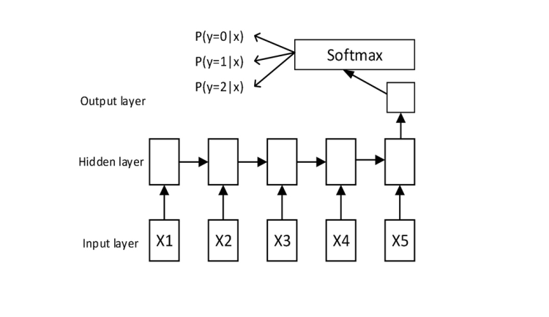
Figure.2.Structure of GRU [5]
As shown in Fig. 2, there is an input layer consisting of several neurons, the number of which is determined by the size of the feature space. Similarly, the number of neurons in the output layer corresponds to the output space. The hidden layer (layers) containing memory cells covers the main functions of GRU networks.[5]

2. Methodology

2.1. Data Description

This study uses real traffic sensor data to analyse and predict traffic conditions.
The experiments focus on data collected by a single sensor station over a period of one month (March 2016), which allows for the analysis of short-term traffic dynamics.

The dataset contains time-stamped measurements of traffic speed and intensity collected from road sensors, which reflect real urban traffic conditions.

Data pre-processing is an important step in ensuring the quality, consistency, and reliability of the input data used to train predictive models. The following pre-processing steps were applied.
The collected dataset was divided into two subsets: training and testing sets. Typically, 80% of the data was used for training the models, while the remaining 20% was reserved for testing. This ensures that the models can be evaluated on unseen data, providing a measure of their generalizability. To standardize the input data and improve model performance, the closing prices were normalized to a range of [0, 1]. Normalization was performed using the MinMaxScaler from the scikit-learn library. This transformation helps in speeding up the convergence of the neural network models during training

2.2 Model Architecture
In this section, we describe the architecture of the GRU and LSTM models .

General Structure Both GRU and LSTM models share a similar architecture with the following components: Input Layer, Hidden Layers, Output Layer

LSTM Model Architecture
Input Layer
The input layer accepts time-series sequences generated using a sliding window approach.
Each input sequence consists of 20 consecutive time steps, where each time step contains one feature representing either traffic speed or traffic flow.
Hidden Layer (LSTM Layer)
- Type: Long Short-Term Memory (LSTM)
- Number of units: 50 LSTM units
- Activation function: tanh (default in Keras LSTM)
- Return sequences: False, meaning that only the last hidden state is passed to the output layer
This layer is responsible for learning temporal dependencies in the traffic time-series data.

Output Layer
- Type: Fully connected Dense layer
- Number of units: 1
- Activation function: linear, as the task is regression-based forecasting
The output layer produces a single predicted value corresponding to the next time step.
GRU Model Architecture

Input Layer:
The GRU model uses the same input structure as the LSTM model.
Each input consists of 20 time steps with one feature per step, representing traffic speed or traffic flow.
Hidden Layer (GRU Layer)
- Type: Gated Recurrent Unit (GRU)
- Number of units: 50 GRU units
- Activation function: tanh (default in Keras GRU)
- Return sequences: False, passing only the final hidden state to the output layer
- The GRU layer captures temporal patterns while using a simpler gating mechanism compared to LSTM.
Output Layer
- Type:
- Fully connected Dense layer
- Activation function: linear
This layer outputs the predicted traffic value for the next time step.

3. Evolution
Optimizer and Loss Function:
The LSTM and GRU models were trained using the Adam optimizer, which is widely used due to its fast convergence and robustness when working with noisy time-series data.
Prediction Metrics:
The performance of both LSTM and GRU models was evaluated using the following metrics:
- Root Mean Squared Error (RMSE):
RMSE measures the average magnitude of prediction errors in the original scale of the data. It penalizes larger errors more heavily, making it suitable for assessing forecasting accuracy in traffic applications.
- Mean Absolute Percentage Error (MAPE):
MAPE expresses the prediction error as a percentage of the true values, which allows for intuitive interpretation and comparison of results across different variables such as traffic speed and flow

4. Results

In this section, I present a comparison of the performance of the LSTM and GRU models for traffic time-series forecasting.
The models were evaluated using Root Mean Squared Error (RMSE) and Mean Absolute Percentage Error (MAPE), which measure the magnitude of prediction errors and their relative scale.
These metrics provide insight into how accurately each model predicts traffic speed and flow based on historical sensor data.

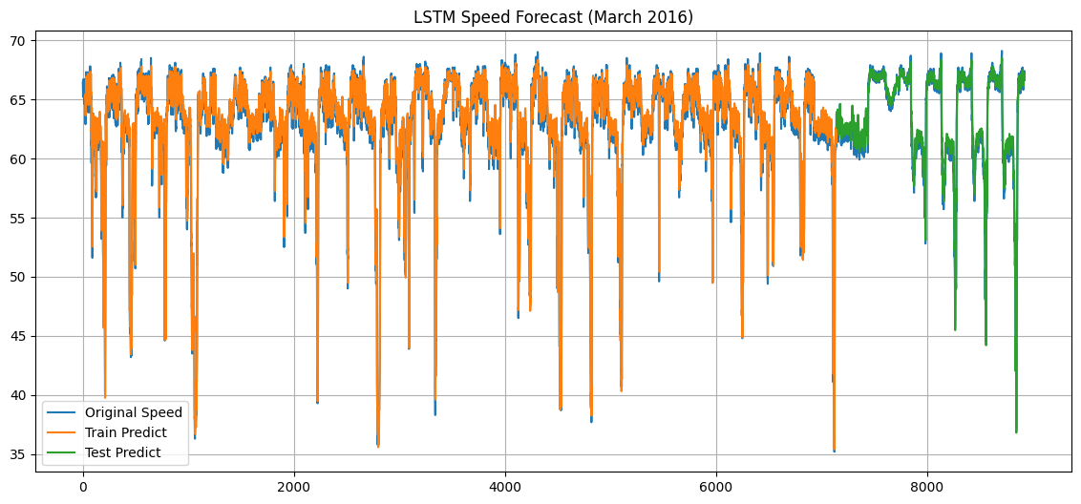

Figure.3. LSTM Speed

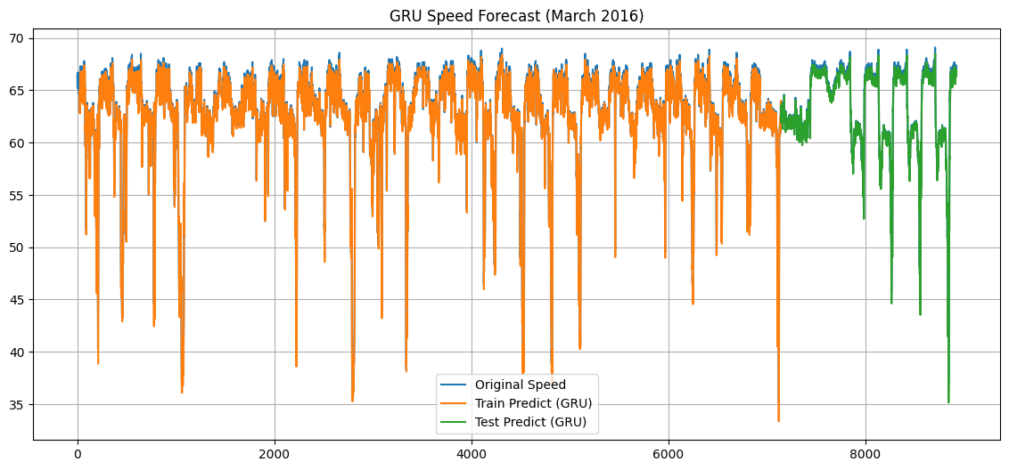

Figure.3. GRU Speed

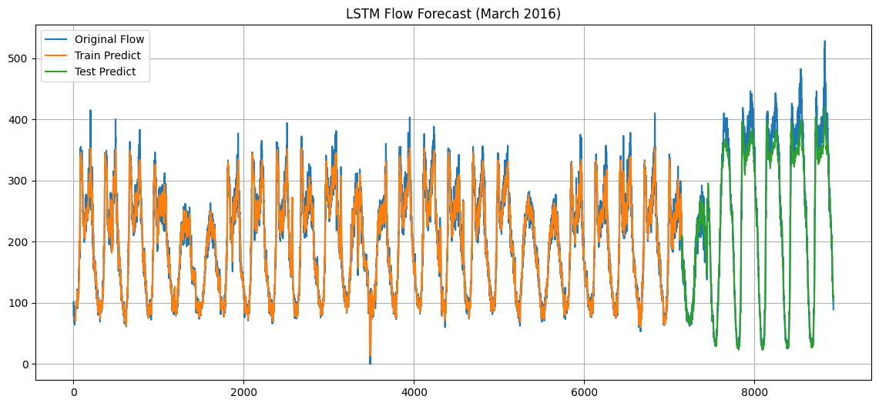
Figure.5. LSTM Flow

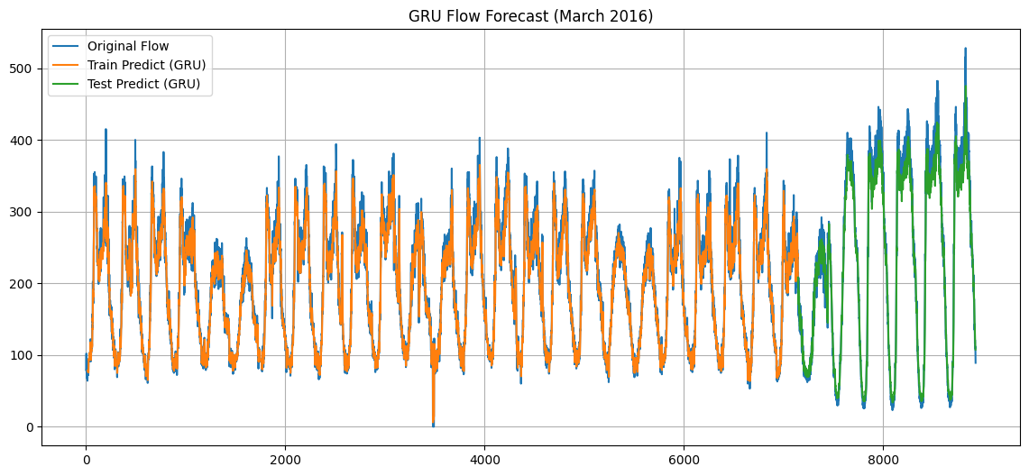
Figure.6. GRU Flow

Performance Metrics
Performance comparison of LSTM and GRU models for traffic speed forecasting using RMSE and MAPE metrics

Model | RMSE | MAPE (%)
LSTM | 22.1 | 8.9
GRU | 22.1 | 8.9

5. Conclusion
Performance evaluations indicate that both LSTM and GRU models are effective in forecasting traffic speed and flow. Experimental results show identical RMSE and MAPE error values, confirming comparable prediction accuracy on the dataset. Both models capture temporal patterns in real-world traffic sensor data. However, GRU’s simpler architecture makes it a more computationally efficient alternative to LSTM, while maintaining similar predictive performance. For traffic forecasting applications that prioritize efficiency and simplicity, the GRU model is a practical and reliable choice.

In future work, the model can be extended to predict traffic further into the future, tested with different model settings, and applied to data from multiple sensors to better reflect real traffic conditions.

6. References

1. Sudiatmika, I. P. G. A., Putra, I. M. A. W.
Comparison of LSTM and GRU Models Performance in Forecasting Gold Prices: A Case Study Using Historical Data from Yahoo Finance.
ARRUS Journal of Engineering and Technology, vol. 4, no. 1, 2024.

2. Huang, C.-J., Kuo, P.-H.
A Deep CNN-LSTM Model for Particulate Matter (PM2.5) Forecasting in Smart Cities.
Sensors, vol. 18, no. 7, article 2220, 2018.
https://doi.org/10.3390/s18072220

3. Su, Z., Jiang, J.
Hierarchical Gated Recurrent Unit with Semantic Attention for Event Prediction.
Future Internet, vol. 12, no. 2, article 39, 2020.
https://doi.org/10.3390/fi12020039

4. Lindemann, B., Müller, T., Vietz, H., Jazdi, N., Weyrich, M.
A Survey on Long Short-Term Memory Networks for Time Series Prediction.
Procedia CIRP, 2021, pp. 650–655.

5. Shen, G., Tan, Q., Zhang, H., Zeng, P., Xu, J.
Deep Learning with Gated Recurrent Unit Networks for Financial Sequence Predictions.
Procedia Computer Science, vol. 131, pp. 895–903, 2018.

